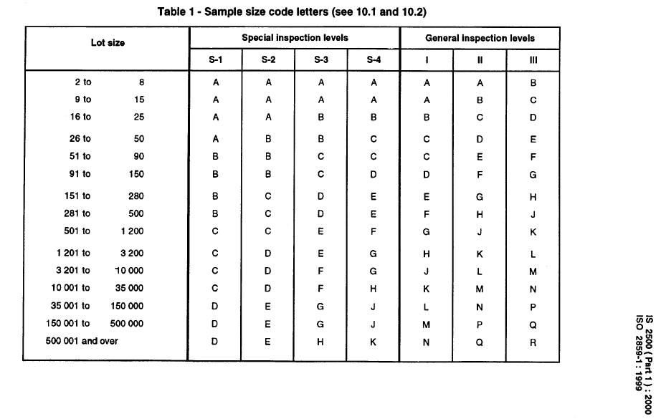Note - Sample sizes are designated by sample size code letters, used to find the applicable code letter for the particular lot size and the prescribed inspection levels.

- Special inspection level S4 for performance parameters
- General inspection level GII for visual inspections
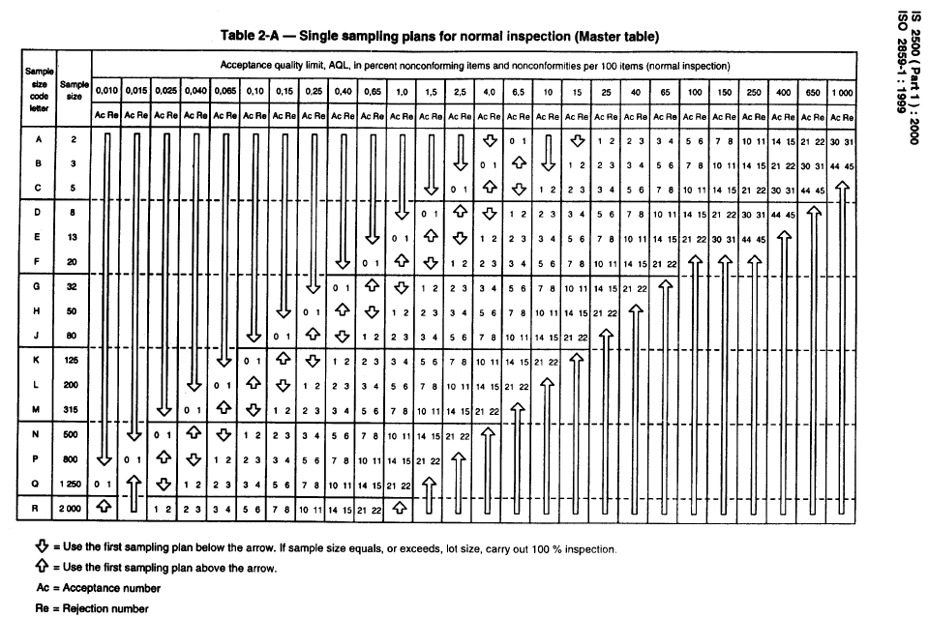

Note – AQL defined as per below criteria

Criteria | AQL
Critical | 0.4%
Major | 1%
Minor | 2.5%

